My Healthy Living Plan Name: Supported by: Week beginning:

To keep well I need to: |  |  | Monday | Tuesday | Wednesday | Thursday | Friday | Saturday | Sunday
Do things to keep happy |  |  | Morning  Supported by: | Morning  Supported by: | Morning  Supported by: | Morning  Supported by: | Morning  Supported by: | Morning  Supported by: | Morning  Supported by:

Getting out


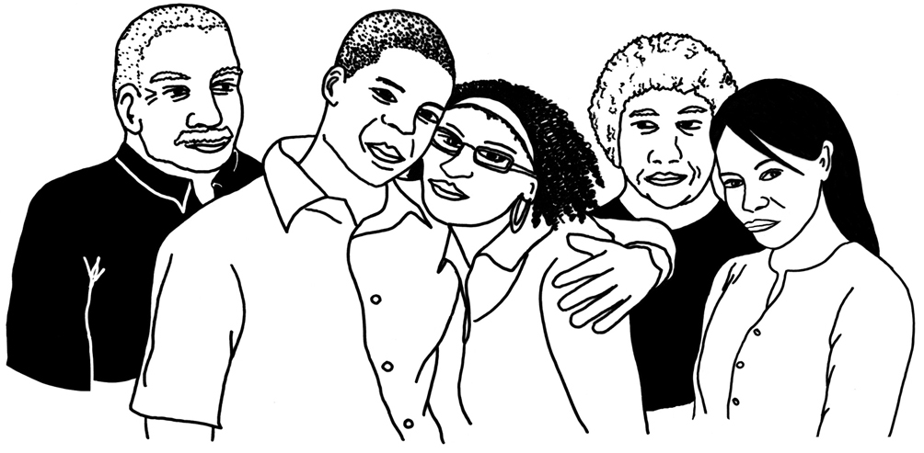
Keeping in touch

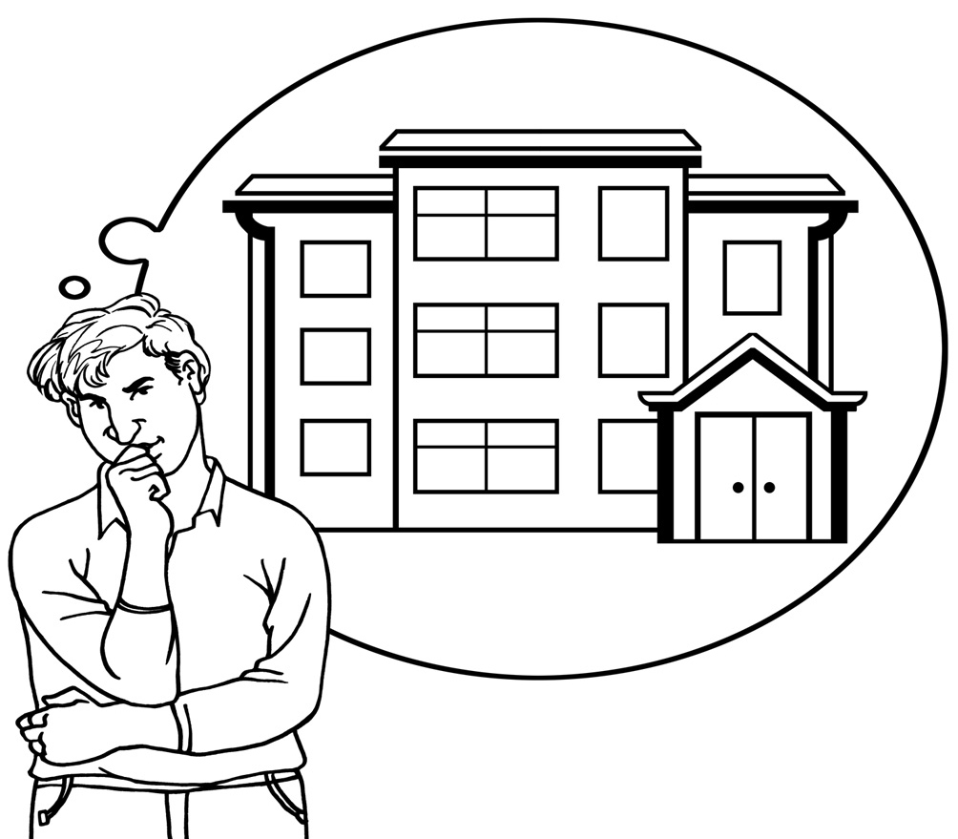  Have a nice home |  |  | Afternoon  Supported by: | Afternoon  Supported by: | Afternoon  Supported by: | Afternoon  Supported by: | Afternoon  Supported by: | Afternoon  Supported by: | Afternoon  Supported by:
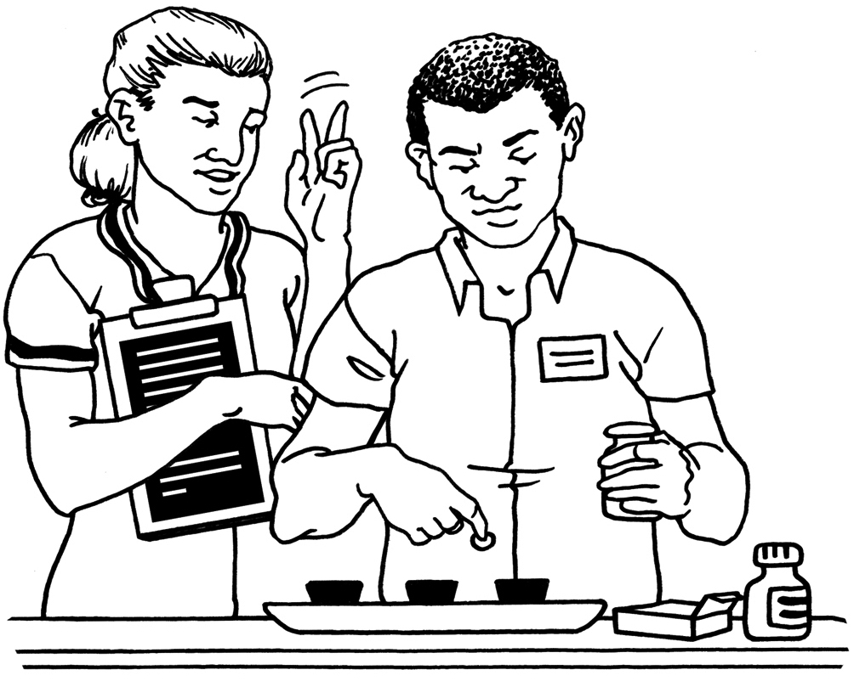
Personal learning

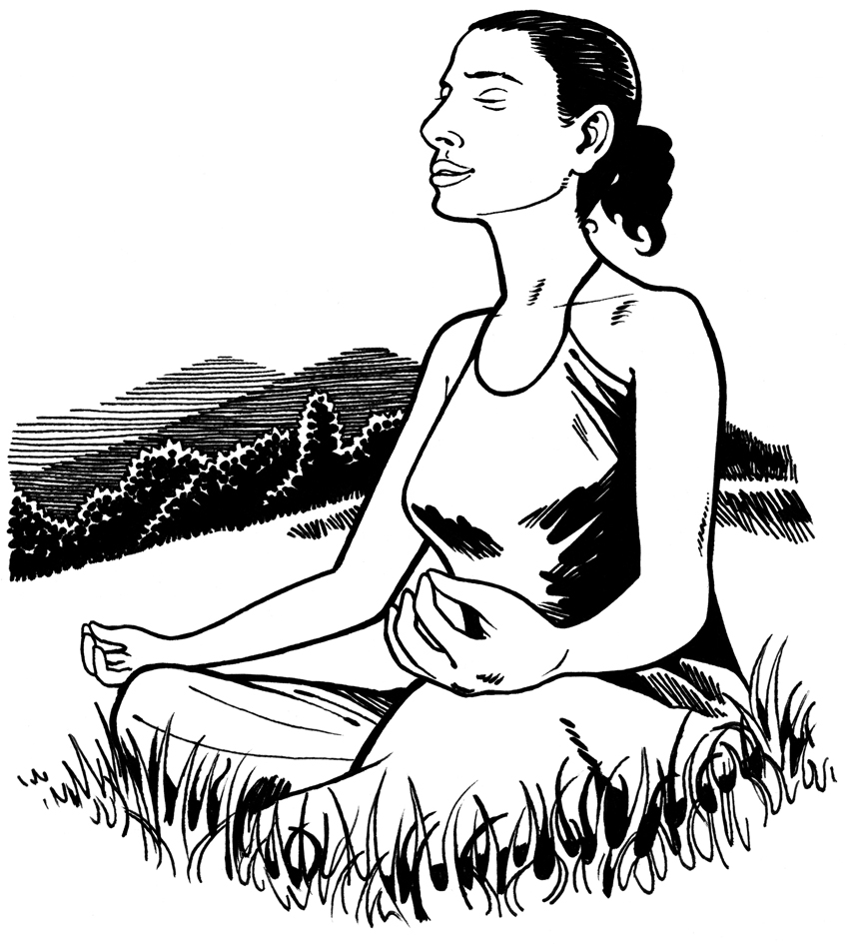
Spiritual needs

Do things to keep healthy
Look after  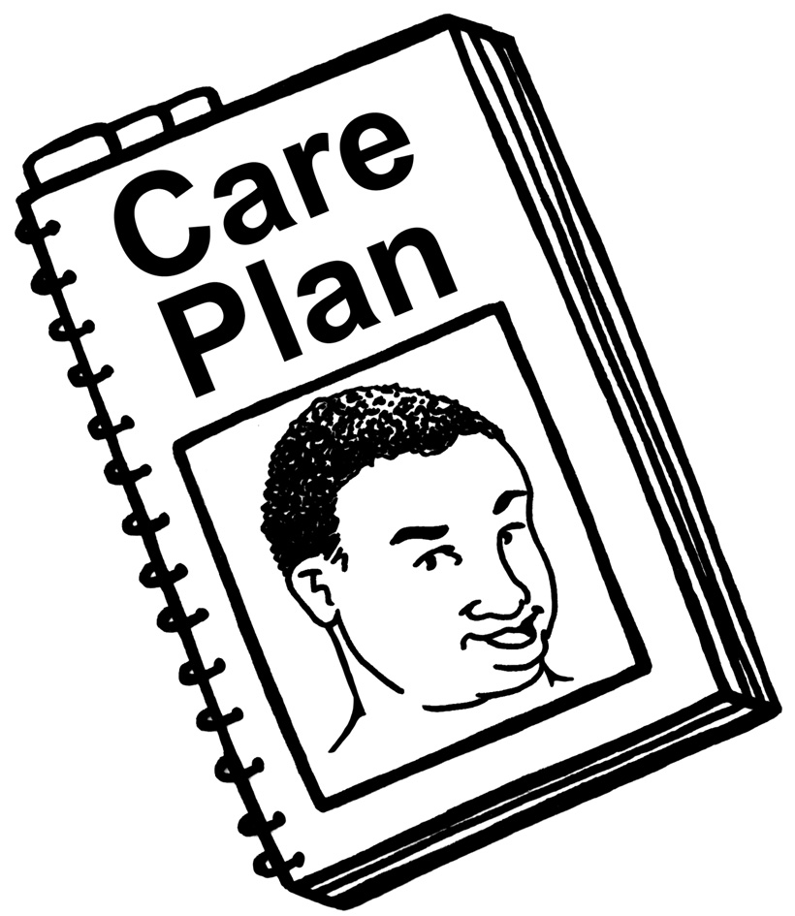  My health |  |  | Evening  Supported by: | Evening  Supported by: | Evening  Supported by: | Evening  Supported by: | Evening  Supported by: | Evening  Supported by: | Evening  Supported by:
Keeping
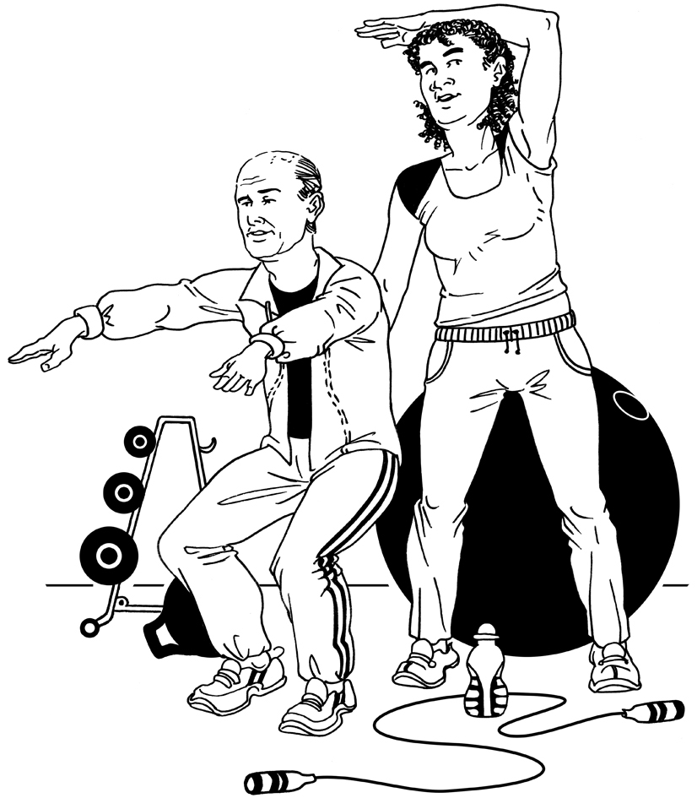
fit


Future dates

and notes:

